Wentzville School District Volunteer Guidelines

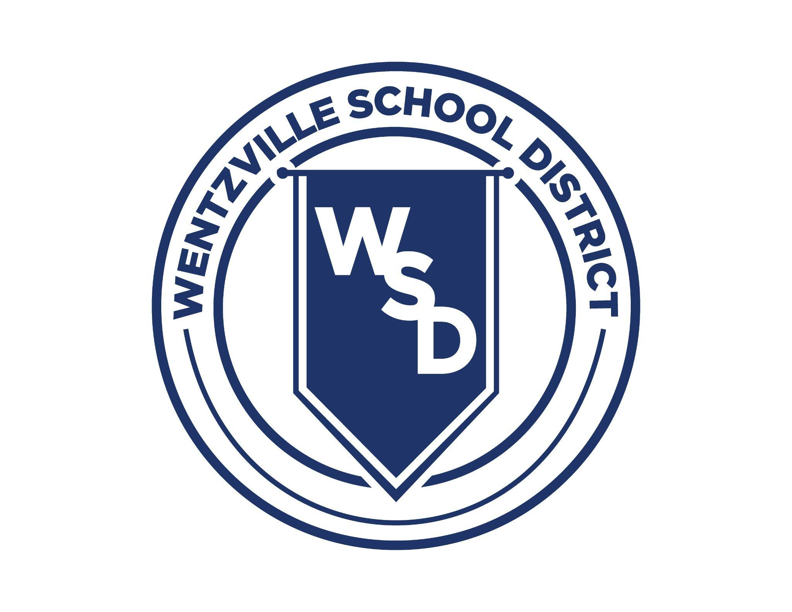

School Volunteers – A Valued Part of the Education Equation

The Wentzville School District Board of Education believes that the use of volunteers within the school, whether during or after regular school hours, enhances the educational process not only for students, but also for the total community. The use of volunteers provides additional support personnel for the classroom, promotes community-school cooperation in facilitating the learning process, increases community support, and provides for individuals who have expertise in various areas to be used as resource persons and on advisory committees.

The Wentzville School District values parents, guardians, and community members who take the time and effort to volunteer in our schools. Volunteers are an important resource that help our teachers, administrators and support staff better serve our students. The District also strives to ensure that the volunteers in our schools are screened to help maintain the safety of our students and staff.

In this document, you will ﬁnd the information and forms that are required of all volunteers.

What Is A Volunteer?

Volunteers in the Wentzville School District come from many different areas in our community, whether a parent or grandparent helping in the classroom, to coaches, mentors and community professionals that share their expertise with special projects and team/activities or other student-oriented groups that support our curriculum and student learning goals. It is the partnership between community and district staff that works to enrich and support the learning and developmental experiences of each student.

Volunteers are deﬁned as individuals who will be in the school to:
- Work with students individually or in small groups under the supervision of the teacher or staff member
- Work inside the school, assisting staff with projects (PTA/PTO Ofﬁcers, etc.)
- Work/organize ﬁeld day activities
- Be a room parent, organize class parties
- Attend ﬁeld trips - work with students individually or in small groups under the supervision of the teacher or staff member

Visitors are also welcome, and are deﬁned as any individual who will be in the school to:

- Eat lunch with your child
- Attend a class party
- Attend assemblies
- Be a guest speaker

All visitors are required to check in to our buildings using Raptor, the visitor management system designed to assist with building security. You will need to use your valid personal ID (driver’s license) to enter the building.

Who May Volunteer?

Selection and recruitment of volunteers are completed at the local school level. Interested individuals should contact the building principal or designee. The volunteer’s interest and abilities are considered when making assignments.

The use of volunteers is encouraged and promoted through the WSD Administrative Center and the schools. Volunteers shall be screened through the Raptor system and the Missouri Family Care Safety Registry and must be acceptable to the administrator. The assignment of volunteers shall be done by the principal or designee and must be acceptable to the teacher. The continuation of the services shall be at the discretion of the administrator. Your approved volunteer status is accessible district-wide; you only need to turn in your forms to one WSD school.

Volunteers will not be discriminated against in relation to age, race, color, creed, religion, national origin, sex or marital status. The Wentzville School District is prohibited from discriminatory practices by the Title VI and Title VII of the Civil Rights Act of 1972, Section 504, and various other state laws and regulations.

In accordance with Missouri State law, persons listed on the sex offender registry may not be present in any school building, on district property, in any district vehicle utilized to transport students, or be present at school activities at any time.

Volunteers are bound by the same code of ethics and all applicable laws as the professional staff. You may view all of our Board of Education policies regarding volunteers on our website found under the About tab.

I Want To Volunteer! How Do I Get Approved?

Level 1 Volunteer

Volunteers will need to complete registration through the Missouri Family Care Safety Registry (FCSR). It provides a more extensive background check than the Raptor system, and is needed for volunteers who spend individual time with students.

Missouri’s Family Care Safety Registry (FCSR) was established by law to promote family and community safety. The registry helps to protect children, seniors, and people with disabilities. The FCSR is being used to access background information on potential volunteers for the Wentzville School District.
  - The Family Care Safety Registry requires volunteers to complete an online registration process that involves a one-time, lifetime fee of $15.25.
  - The registration and fee will be the responsibility of the volunteer.
  - The online registration process can be found at FCSR-BSEES - MO.gov.
(NOTE: This registration process CANNOT be completed on a mobile browser/device.) Details on how to register can be found on the WSD website.
  - New WSD Volunteer Registration forms will be required each school year to run a current background screening if you would like to participate in volunteer opportunities.

Once the online portion is complete, paper WSD Volunteer Registration Form A
and Form B must be completed and submitted to your student’s school. Please note, the wait time for the FCSR registration to be processed and for the District to be notiﬁed can be up to four weeks. We recommend completing this process as early as possible. Your approved volunteer status is accessible district-wide; you only need to turn in your forms to one WSD school.

Level 2 Volunteer

Any volunteer/mentor who will be traveling with a student group for an overnight trip or working closely one-on-one with students must complete the Level 1 Volunteer process and also submit to an FBI/Highway Patrol Background check which includes ﬁngerprinting. The cost is $41.75, paid by the applicant. Your completed ﬁngerprint check is good for ﬁve (5) years. Please allow a minimum of four weeks before your planned trip or volunteer event.

The FBI/Highway Fingerprint application is available only through the District Volunteer Coordinator or the WSD Communications & Community Relations Ofﬁce. Please email the District Volunteer Coordinator: info@wsdr4.org.

Application is online only. You will receive an email with instructions for registering to have your ﬁngerprinting completed.

Where to Obtain Volunteer Forms or other Information?

See the Volunteer Guidelines on the District website.

If you have any questions about policy, practices, or procedures, please contact the local school ofﬁce, the District Volunteer Coordinator, or the Communications & Community Relations Department.

District Volunteer Coordinator - Communications & Community Relations Department:

info@wsdr4.org; 636-327-3800, ext. 20358.

Thank you for your interest in volunteering in our schools!

